Lab 9
Course
CourseID | Name | EntryQualification
C01 | Diploma | 3 credits in O Level
C02 | Degree | 3 credits in A Level
C03 | Master | Degree in any computing field
C04 | Foundation | 5 credits in O Level

Primary key: CourseID
Student
StudentID | Name | Gender | DOB | CourseID
ST01 | Helen | Female | 2 Feb 1999 | C01
ST02 | Karen | Female | 15 Sept 2000 | C02
ST03 | Peter | Male | 28 April 1997 | C02
ST04 | Shaun | Male | 30 June 2001 | C03

Primary key: StudentID, Foreign key: CourseID
Subject
SubjectID | Name | CourseID
SU01 | SAD | C01
SU02 | IDB | C01
SU03 | ISWE | C02
SU04 | CPP | C02
SU05 | Java | C03
SU06 | NNT | C04
SU07 | DAS | C04

Primary key: SubjectID, Foreign key: CourseID

Attributes | Data Type
CourseID | nvarchar(50)
Name | nvarchar(50)
EntryQualification | nvarchar(50)

Attributes | Data Type
StudentID | nvarchar(50)
Name | nvarchar(50)
Gender | nvarchar(50)
DOB | Date
CourseID | nvarchar(50)

Attributes | Data Type
SubjectID | nvarchar(50)
Name | nvarchar(50)
CourseID | nvarchar(50)

- Create a new Database Lab9
- Create 3 tables given above (remember to specify the primary & foreign key)
- Insert each row of data into the tables
- Generate the database diagram
Execute this statement first: (if you are not the admin of your PC/laptop)
Alter Authorization on Database::Lab9 To [sa];
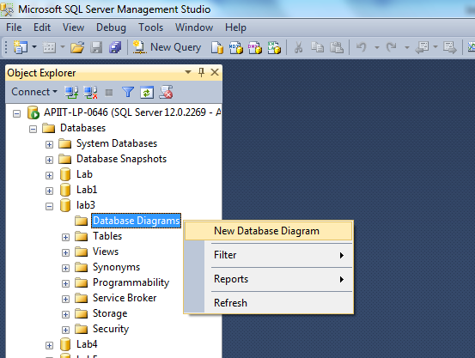

- Display StudentID, Name and Age (derive Age from DOB) hint: use getDate(), dateDiff()
- List all students whose age is more than 18
- Inner Join Course, Student and Subject table
- Join all columns from Course, Student and Subject table without using the keyword ‘JOIN’
- Join all columns from Course and Subject table without using the keyword ‘JOIN’
- Left Join Course with Student table, order by Course name (Course is left, Student is right)
- Right Join Course with Student table, order by Student name (Course is left, Student is right)
- Show the course where no student enrolled in. (can use join / subquery: not in, not exists)
- Show students who enrolled in diploma course (can use join / subquery)
- Show the subjects which belongs to diploma course (can use join / subquery)
- Show the students who enrolled in degree course and studied ISWE subject (can use join / subquery)

Reference:
https://www.w3schools.com/sql/default.asp

